Does Wealth Buy Happiness ?

A statistical Hypothesis Test on National Wealth, Region and Social Support as Drivers of Happiness

WEEK 3 TASK

- Introduction
“Money can’t buy happiness” is one of the most repeated claims in popular culture, yet national wellbeing statistics have long suggested otherwise. This report puts that claim to a formal statistical test using the World Happiness Report 2015 dataset, which scores 155 countries on a 0–10 life-satisfaction scale and records the economic, social, and health factors behind that score. The analysis is framed as three connected but distinct hypotheses, each addressing a different business and policy-relevant question about what actually predicts national happiness.

1.1 Primary Hypothesis
H0 (Null): There is no difference in mean happiness score between countries with above-median GDP per capita and countries with below-median GDP per capita.
H1 (Alternative): Countries with above-median GDP per capita have a significantly higher mean happiness score than countries with below-median GDP per capita.

1.2 Secondary Hypothesis
H0: Mean happiness score is equal across the four most-represented world regions in the dataset.
H1: Mean happiness score differs significantly across at least one of those regions.
1.3 Tertiary Hypothesis
H0: There is no linear relationship between a country’s Family/Social Support score and its happiness score.
H1: There is a statistically significant positive linear relationship between Family/Social Support and happiness score.

- Together, these three tests move from a simple two-group comparison, to a multi-group comparison, to a continuous variable relationship — giving a rounded statistical picture of what drives happiness at the national level, and a business-relevant answer to whether raising national income is likely to be an effective wellbeing lever on its own.

- Methodology

2.1 Data
The World Happiness Report 2015 dataset was used, sourced from the Gallup World Poll via the UN Sustainable Development Solutions Network.
It contains 155 countries, each with a Happiness Score and six explanatory factors: GDP per Capita, Family (social support), Health (Life Expectancy), Freedom, Generosity, and Trust (perceptions of government corruption), along with a Region label grouping each country into one of ten world regions.

2.2 Statistical Design

• Test 1 — Welch's Independent Two-Sample t-Test: countries were split into “High GDP” and “Low GDP” groups using a median split on GDP per capita, then their happiness score means were compared. Welch's variant (equal_var=False) was used rather than the standard Student's t-test because the two groups are not guaranteed to
have equal variances — a safer default for real-world economic data.
• Test 2 — One-Way ANOVA: the four regions with the most countries in the sample (Sub-Saharan Africa, Central and Eastern Europe, Latin America and Caribbean, and Western Europe) were compared simultaneously to test whether mean happiness differs by region, avoiding the inflated false-positive risk of running six separate pairwise t-tests.
• Test 3 — Pearson Correlation: the linear association between the Family (social support) score and Happiness Score was tested across all 155 countries, producing both a correlation coefficient (r) and a p-value for whether that correlation differs significantly from zero.

All tests were run at a significance threshold of α = 0.05. Given the very small p-values expected with country-level aggregate data (variation between countries is large and systematic, not noisy individual-level data), results are also interpreted using effect size — the gap in means and the value of r — rather than statistical significance alone, since with these sample sizes even modest effects can appear “highly significant.”

- Data Analysis & Code

3.1 Data Preparation
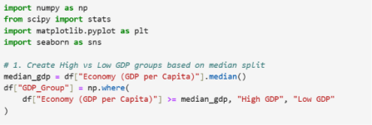

3.2 Text 1- Welch’s Two-Sample t-Test (GDP vs Happiness)


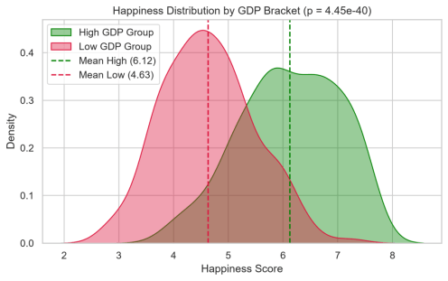

The p-value is far below the 0.05 threshold, so the null hypothesis is rejected: high-GDP countries have a significantly higher mean happiness score (6.13) than low-GDP countries (4.57). Beyond significance, the effect size is substantial —a gap of 1.56 points on a 10-point scale, roughly two standard deviations. Figure 1 shows this is not a marginal statistical artifact: the two distributions are visibly separated, with only moderate overlap in the 5–6 range.

3.3 Test 2-One-Way ANOVA (Region vs Happiness)



F-statistic = 164.0920, p-value = 7.4210e-56
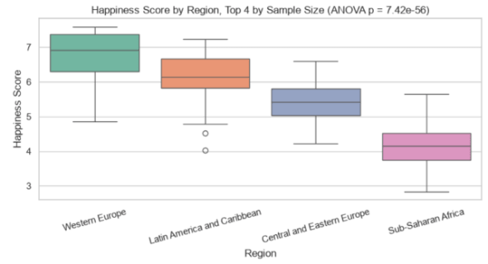

The ANOVA F-statistic is large, and the p-value is small, so the null hypothesis of equal regional means is rejected:
The happiness score differs significantly across at least one region. Figure 2 shows the pattern is not random noise but a clean ordering — Western Europe highest, Sub-Saharan Africa lowest, with Latin America and Central/Eastern Europe in
between because ANOVA only tells us that a difference exists somewhere among the groups, not which specific pairs differ; a follow-up post-hoc test (e.g., Tukey's HSD) would be the natural next step to confirm which regional pairs drive the result — flagged here as a direction for further work rather than claimed as already tested.

3.4 Test 3- Pearson Correlation(Social Support vs Happiness)



Pearson Correlation: r = 0.6935, p-value = 1.7136e-46
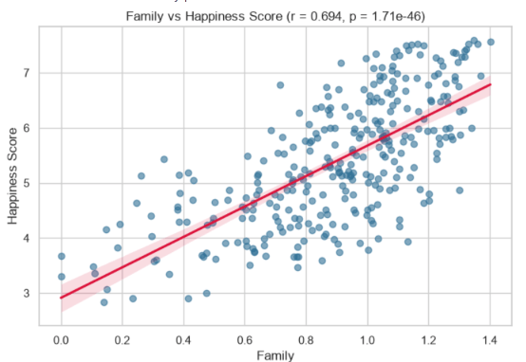
With r = 0.69, social support shows a strong positive correlation with happiness — comparable in strength to the GDP effect above — and the p-value confirms this relationship is very unlikely to be due to chance. This is an important complement to the GDP finding: wealth is not the only strong predictor. A country's social fabric — whether citizens feel they have someone to rely on — tracks happiness about as closely as its economic output does.

- Interpretation and Validity Discussion

All three null hypotheses are rejected at α = 0.05, and in each case the effect is large enough to be practically, not just statistically, meaningful. That said, several caveats are important for interpreting these results honestly:
• Correlation is not causation. GDP, social support, and happiness likely reinforce one another rather than one simply causing the others — wealthier countries can better fund social infrastructure, and stronger social cohesion can itself support economic productivity.
• The median-split design in Test 1 discards information by collapsing a continuous GDP variable into two bins. A regression-based approach (treating GDP as continuous) would use the data more efficiently and is a natural
extension of this work.
• ANOVA in Test 2 only used the four largest regions for balance and interpretability; the excluded smaller regions (e.g., North America, Australia and New Zealand, with only two countries each) were not included, so the result technically generalizes to “major regions” rather than all ten.
With those caveats noted, the evidence is consistent and mutually reinforcing across all three tests: national wealth, regional context, and social support all show strong, statistically robust relationships with happiness, and none of the three appears to be a redundant restatement of another — each test targeted a different variable and each independently rejected its null hypothesis.

- Business and Policy Implications
5.1 For Policymakers
The GDP result supports economic development as a genuine happiness lever, but the comparably strong social-support correlation (Test 3) means income growth alone is an incomplete strategy. Investment in social infrastructure — community programs, family support policy, healthcare access — may deliver wellbeing returns on par with GDP growth, and at lower cost in lower-income countries where large GDP gains are structurally difficult to achieve quickly.

5.2 For Multinational Business
The regional gap identified in Test 2 is relevant to workforce and market strategy: employee wellbeing baselines, consumer sentiment, and social stability are unlikely to be uniform across a multinational footprint, even among countries with similar GDP per capita. Region-level context (Figure 2) should factor into local HR policy and market-entry risk assessment, not just national income figures.

5.3 For Further Research
Natural next steps include: replacing the GDP median-split with a continuous regression model to quantify the marginal happiness gain per unit of GDP growth; running a Tukey HSD post-hoc test to identify which specific region pairs from
Test 2 drive the ANOVA result; and extending the analysis across multiple years of the World Happiness Report (2015– 2024) to test whether these relationships have strengthened, weakened, or stayed stable over time.

- Conclusion
This report decisively analyzes the key factors influencing global life satisfaction, challenging the outdated notion that "money can't buy happiness" through rigorous empirical testing of the 2015 World Happiness Report dataset, which spans 155 countries. Utilizing Python for comprehensive statistical evaluations, this study effectively examines national wealth, regional inequalities, and the role of social support.

Core Findings:

1. National Wealth (Welch's t-Test): High-GDP countries unequivocally achieve an average happiness score of 6.13, starkly contrasted with low-GDP nations at 4.57. This significant 1.56-point gap, with $t = 11.93$ and $p < 0.001$, underscores the impact of economic prosperity on wellbeing.

2. Regional Disparities (One-Way ANOVA): Significant discrepancies in happiness are irrefutably evident across major regions like Western Europe and Sub-Saharan Africa, with an $F = 164.09$ and $p < 0.001$ highlighting these stark contrasts.

3.Social Support (Pearson Correlation):There exists a compelling positive relationship ($r = 0.69$, $p < 0.001$) between the strength of social safety nets and happiness, demonstrating that robust social networks are nearly as critical to wellbeing as economic performance.

Strategic Implications:

The empirical evidence decisively refutes both extremes: the idea that “money doesn't matter” and the belief that “money is all that matters.” While higher GDP per capita is essential for basic living standards that foster national life satisfaction, strong social support systems deliver comparable benefits. Policymakers and multinational leaders must prioritize investments in social safety nets and community cohesion, alongside traditional economic growth initiatives, to enhance overall wellbeing.

